Add function:  
  
checkout function:



Cloning function:

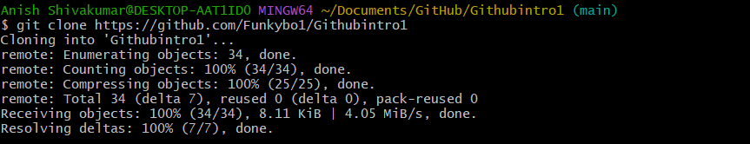

pull function:

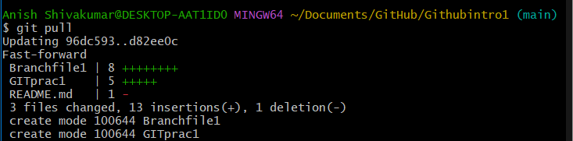’

Fetch function:

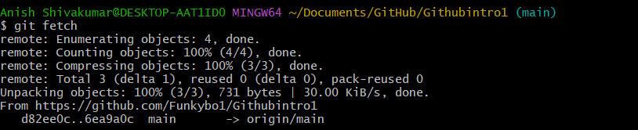

Commit function:



Commit -a function:

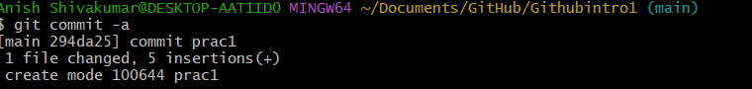

Merge function:

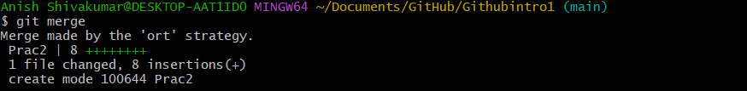

Pull function:



Reset function:



Rebase function:

